Lab 10: Polymorphism
Objective:
- The objective of this lab is to teach students how to implement Polymorphism in C++.
- Understand runtime polymorphism using virtual functions
- Practice function overriding in derived classes
- Use base class pointers or references to achieve polymorphic behavior
Learning Outcome:
- After this lab, students will be able to implement polymorphism.
Problem Statement
Design a payroll system for a company with different types of employees. The goal is to use polymorphism to calculate salaries for various employee roles, where each type has a different way of computing pay.
Tasks to do:
Create following classes with given data members and member functions/methods.
1. Employee (Base Class)
- Protected member: name
- Public virtual method: calculateSalary()
- Public method: displayInfo() that displays the employee name
- Constructor: Accepts a name and initializes the name member.
- Destructor: Declare as virtual to allow safe polymorphic deletion. Display message as per sample output.
2. FullTimeEmployee (Derived Class)
- Inherits from: Employee
- Additional members: basicSalary, allowance
- Overrides: calculateSalary() to return basicSalary + allowance
- Constructor: Accepts name, basicSalary, and allowance. Calls base class constructor to initialize name.
- Destructor: Display message as per sample output.

3. PartTimeEmployee (Derived Class)
- Inherits from: Employee
- Additional members: hoursWorked, hourlyRate
- Overrides: calculateSalary() to return hoursWorked * hourlyRate
- Constructor: Accepts name, hoursWorked, and hourlyRate. Calls base class constructor.
- Destructor: Display message as per sample output.

4. ContractEmployee (Derived Class)
- Inherits from: Employee
- Member: contractAmount
- Overrides: calculateSalary() to return contractAmount
- Constructor: Accepts name and contractAmount. Calls base class constructor.
- Destructor: Display message as per sample output.

In your main() function:
  - Create an array or vector of Employee* or Employee& pointing to objects of each derived class.
  - Call displayInfo() and calculateSalary() polymorphically
  - Print the salaries using only base class pointers
Sample Output
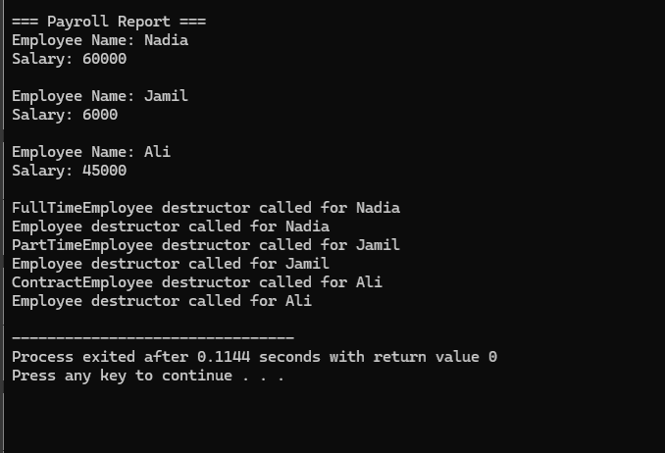
Practice Question:
Develop a notification system that can send alerts via different channels like email, SMS, and push notifications. Each notification type behaves differently when sending a message. The system must handle all notifications using polymorphism to treat them generically.
Tasks to Do:
Create following classes with given data members and member functions/methods.
- Notification (Base Class)
  - protected member: recipient
  - public virtual method: send()
  - public method: setRecipient() and getRecipient()
- EmailNotification (Derived Class)
  - Inherits from Notification
  - Overrides send() to print: "Sending Email to [recipient]"
- SMSNotification (Derived Class)
  - Inherits from Notification
  - Overrides send() to print: "Sending SMS to [recipient]"
- PushNotification (Derived Class)
  - Inherits from Notification
  - Overrides send() to print: "Sending Push Notification to [recipient]"
In your main() function:
  - Create an array or vector of Notification* pointing to objects of each derived class
  - Set a recipient for each notification using setRecipient()
  - Loop through the collection and call send() polymorphically
Observation:
Remove the virtual keyword from the base class method and observe the effect on output.

